

Kaiser Permanente is proud to announce the success of the release of the Health4U application for all of its patients and subscribers. Health4U was designed to encourage users to focus on their fitness and eating habits, which in the process reduces everyone’s health care coverage costs in the long term. Diseases such as Heart Disease and Type 2 Diabetes are easily preventable through regular moderate physical activity. 3 out 4 Americans do not get enough physical activity and there is an estimated $117B in health care costs that are preventable. The application hopes to make a difference in this.

The Health4U application includes a place where users can create goals from preset to customized plans. Users can view all of their health-related data and progress goals. For an added bonus, users can achieve rewards through their progress towards their goals. By providing an easy application with rewards, the application encourages users to be more active in their health goals.

Since release, Health4U has amassed over 15,000 new users with a growth of about 25% every week. Below there is a basic outline of some of the screens from the application (Goals Section).

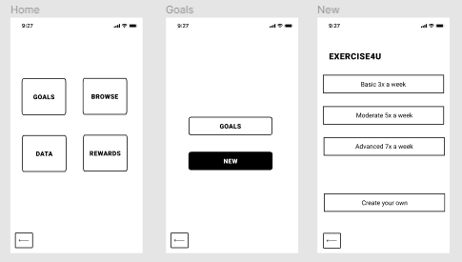

The next steps are to monitor activity on the application for any feedback and incorporate if necessary. Health4U will also be making new features to be available in the near term.

Thanks,  
Dixon and the Health4U Team